**Project Design Phase-II**

**Technology Stack (Architecture & Stack)**

|  |  |
| --- | --- |
| Date | 29 October 2022 |
| Team ID | PNT2022TMID07540 |
| Project Name | Project – Smart Farmer-IoT enabled farming application |
| Maximum Marks | 4 Marks |

**Technical Architecture:**

Mobile

Temperature

humidity,

Farmer

SMS alert

Sensors

 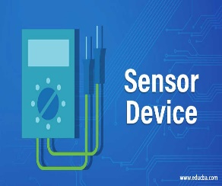 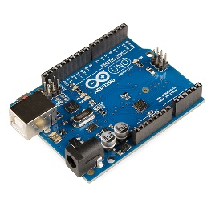 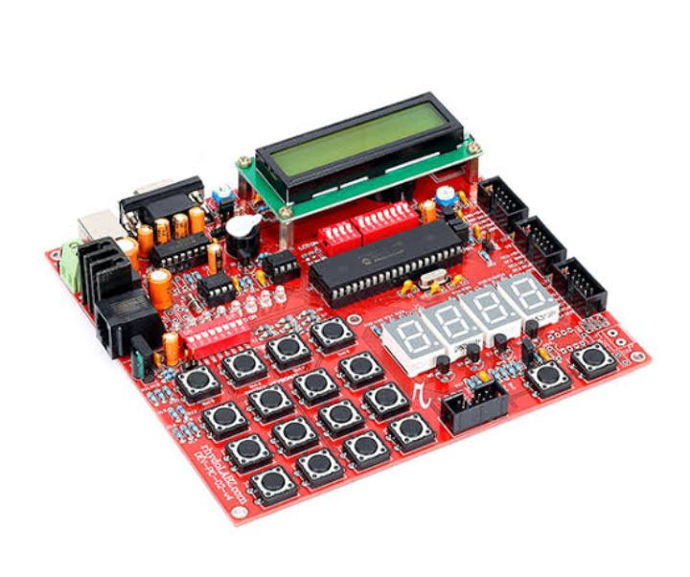

**FARMING LAND SENSORS ARDUINO EMBEDDED C**

 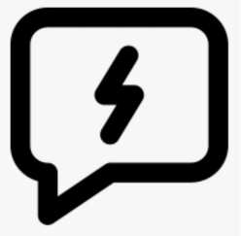

**AUTHORITIES WEB UI MOBILE APP FAST SMS**

**Table-1 : Components & Technologies:**

|  |  |  |  |
| --- | --- | --- | --- |
| **S.No** | **Component** | **Description** | **Technology** |
| 1. | Received data from sensors | The information gathered from the sensor units installed along rivers | ESP32 wifi module |
| 2. | Web interface | The gathered information was presented visually | HTML,CSS, javascript |
| 3. | Database | Datatype | MySQL |
| 4. | Data Storage | Storage needs for files | IBM Block storage |

**Table-2: Application Characteristics:**

|  |  |  |  |
| --- | --- | --- | --- |
| **S.No** | **Characteristics** | **Description** | **Technology** |
| 1. | PH level monitoring | By kept sensors on the farming land it will detect the pH of land | PH-sensor |
| 2. | Temperature monitoring | It will detect the atmosphere temperature | Temperature sensor |
| 3. | Irrigation monitoring | Water level detecting | DTH11 Sensor |